**“Paws Out”**

**Final Project Report**

**December 12, 2019**

**Table of Contents**

**Executive Summary** **3**

Project Overview 3

Purpose and Scope of this Specification 3

**Product/Service Description** **3**

Product Context 3

User Characteristics 3

Assumptions 4

Constraints 4

**Requirements** **4**

User Interface Requirements 4

Usability 5

Performance 5

Capacity 5

Availability 5

Manageability/Maintainability 5

Monitoring 5

Maintenance 5

Operations 6

Security 6

Protection 6

Authorization and Authentication 6

Data Management 7

**User Scenarios/Use Cases** **8**

**Specifications** **8**

**Software Code** **10**

**Physical Prototype** **12**

**6. Future Design Steps/Project Schedule** **13**

**7. Learning Statements** **14**

# ***Executive Summary***

## ***Project Overview***

To eliminate the need for the dog owner to have to let the dog out, we have decided to recreate the doggie door. Our project, Paws Out, will feature three main parts that should be implemented before the end of next semester; a doggie door, pressure sensor mats (attempt for implementation in part 2) and an interactive app. Mats will be placed both on the inside and outside of the door. If your dog needs to go outside they will stand on the indoor mat. Once pressure is detected for at least 30 seconds a notification will be sent to the dog owner's app, **“Who let the dogs out?”**. One the application side the camera built into the door will show video of the dog ready to go out. There will be an action called for in which the owner has to accept the request. Once outside the owner will see the dog go outside and the door will immediately close behind the dog.The same process will happen to accept the dog back in the home.

## ***Purpose and Scope of this Specification***

Describe the purpose of this specification and its intended audience. Include a description of what is within the scope of what is outside of the scope of these specifications. For example:

**In Scope**

This document addresses requirements related to completion of the doggy door and its operations

* Functionality of pressure pad to work for Dogs (attempt for implementation in part 2)
* Functionality of RFID sensor and Ardunio for access
* App and website cohesion

**Out Of Scope**

* Functionality of the Camera for later stages of development
* Adaptation for use with other animals other than dogs

# ***Product/Service Description***

## ***Product Context***

How does this product relate to other products? Is it independent and self-contained? Does it interface with a variety of related systems? Describe these relationships or use a diagram to show the major components of the larger system, interconnections, and external interfaces.

“Paws Out” doggie door is similar to other automatic doggie doors on the market. Our product sets itself apart by the way that there is an app that is connected to the door to allow access in

and out the house.

## ***User Characteristics***

**Persona #1:**

Ashley Hawthorne

Full-Time Student, Part-time worker

Owns 1 dog, Class schedule and work schedule doesn't allow her to go home and take out her dog Max

**Persona #2**

Tom Crandell

Part-time College IT Professor, Part time Student enrolled in Master’s Program

Owns 4 dogs

Has to go home and take out the dog between classes and is usually late traveling back to school

Has experience in networking

## ***Assumptions***

In order for a user to have this device installed. There needs to be a doggie door or a door that can be cut into to install wiring. It is also assumed that the user will have wifi. In order to get notifications that your pet needs to go outside, there needs to be a connection in your home. It is also assumed that, for remote instances, you will need a mobile device. This can be a phone or table or anything that can download applications.

## ***Constraints***

Describe any items that will constrain the design options, including

* Using the app with previous versions of IOS and Android respectively.
* Security for the doggy door to ensure unwanted animals cannot enter.
* Making sure the hardware being the Arduino can take the strains of the door systems over time.
* Design, how the door is designed for use in all homes with different types of doors
* Programming language, making sure that the Arduino can work with python and other programming languages for future updates.
* Implementation of Pressure pad support into current code.

# ***Requirements***

## ***User Interface Requirements***

* For use with the app
  + The user should have a splash page were they would login with their Paws out Username and password
  + A tab for uses of logged Entry/Exit of the Dog
  + A place to view the door with the camera
  + Notifications
* For Use with the Website
  + Product page
  + User Login area
  + About the app/company

## ***Usability***

Learnability

* Owner must have WiFi
* Must have the most update iOS and Android device
* Must create a user login(case sensitive password)

## ***Performance***

Specify static and dynamic numerical requirements placed on the system or on human interaction with the system:

* The app supports up to 5 logins
* Only 2 people can be logged on at the same time
* Compatible with all iOS and Android powered devices

### **Capacity**

The Paws Out doggy door is compatible for one dog at a time. The mat will go off of the weight of the dog as he/she stands or sits for about 15 seconds.

### **Availability**

Measurable requirements for:

* 24 hours
* Always available using our mobile app
* Coverage for geographic areas

## ***Manageability/Maintainability***

### **Monitoring**

One of the things my team and I would like to implement later on is a scheduling track. So compiling data over time (i.e. how many times a day, what times a day, duration of putting, etc) the system will have learned the dogs behavior and created a schedule to make the system automated. This can be achieved by logging all activity in a database which will also service the dashboard for the users leisure. The owner of course can opt out of this feature if they would like total control of if you know your dog is unpredictable.

### **Maintenance**

There isn't any real maintenance to be done to this system. Every few months or so an updated version may need to be installed through the app. We will always be working to make our product better, so once a new feature is added or upgraded, notifications for system upgrades will be sent to “Paw Me Out” application just as Apple does with their OS.

### **Operations**

The following is how the door will operate, how data is processed and safety considerations when it comes to the opening of the doggie door.

* In idle times, for instance when the dog is outside, the camera is a feature that doesn't need to be on unless the owner wants a stream going to monitor the dog while it is outside. Inside or outside, the RFID reader doesn't need to be searching for anything until it senses the collar is within a set proximity for a set amount of time just in case the god is just passing by.
* Data processing includes calculating the weight of the animal. The mat will be able to determine if the weight should be accepted or alerted to the owner based on initial programmed settings. The RFID collar chip and reader will be uniquely programmed to only match that of what you attach to your dogs collar. No other dogs RFID chip should be able to be read by the reader in your doggie door.
* Safety consideration include knowing the weight of your animal, a camera on the door that points out onto the porch where the mat is and RFID sensor. Inorder for these parts to work you need the RFID chip in the collar along with the reader in the mat or door. There also needs to be a camera mounted somewhere near the door that displays the mat and surrounding areas.

.

## ***Security***

### **Protection**

The main component of this system is for the owner to accept the the Dogs “request” to go outside. The owner will get a request notification only if:

* Correct weight is detected on the mat
* Inside mat has been activated first

Then, the owner will be able to accept the request. Upon request, before the door opens:

* Door will read RFID in collar

If outside mat is triggered first, an alert should be sent to the owners device including the weight of the object. A camera on the door will allow for the owner to look at their front porch or wherever the outside mat is. In a way, this can be used as a typical home security system that alerts you when someone or something is at your door that is not your animal. Once the owner accepts the request and no RFID signal is picked up, the door will refuse the request. As a responsible dog owner, your dog should always have on some kind of collar for identification so this aspect shouldn't be anything to worry about.

### **Authorization and Authentication**

For authentication factors, we have decided to add a collar on the dog and a weight identifier. With the collar, the door cannot open for the animal unless its close enough to enter. This will use an RFID sensor. For the weight factor, we the owner will be able to set the expected weight for their animal(s). Weight distribution is another factor we will use. Dogs will have to be trained to sit in the middle of the matt. Multiple sensors in the mat will be able to sense the distribution of the weight of the animal. This way, with all of these factors, no stray animals or even humans can get into your doggies door and into your home. the RFID sensor acts as a chip reader. So even though you may get a notification that your god is waiting at the door and you allow the door to be raised, it will not raise unless the collar is on. We also plan to include a “sequence observer”. By this we mean that the door will open according to previous activity. For example, if you have more than one dog and they both go out and different times, the outside mat should open for each individual dog twice. The outside mat should not activate the door unless the inside has been activated first. If something tries to come in from the outside and your animal hasn't gone out, there should be an alert that something is trying to come in without first having permission to exit the home.

## ***Data Management***

Specify the requirements for any information that is to be placed into a database, including

* **Types of information used by various functions**
* **data entities and relationships:**
  + In a table, entities can be the actual pets. The other entities may include something along the lines ofthe mat, and RFID reader. In terms of relationships, the relationship between the pet and the mat would be how many times a day they stood on the mat and for how long. A relationship between the mat activation and the door rising could exist for the purpose of comparing how many times the mat was activated to the times the door was open to analyze the number of false alerts/requests.
* **valid range, accuracy, and/or tolerance :**
  + As we all know dogs eat. For dogs not on a fixed diet where the food selection and quantity fluctuates, there would be a little wiggle room for detecting a dogs weight. For example, your dog weighs 12 pounds one day, got into the dog food and had a feast the next, and now weighs 14 pounds. We will allow for a window of a five pound range allowing it to send notifications if 2 pounds above and below the normal set weight are detected.
* **units of measure:**
  + There are a few different units of measurement used for this system. The first would be ounces/pounds for the mat as it is programmed to detect the weight of YOUR pet. Another unit of measurement we would observe is distance in inches. This is used for RFID to identify that this is indeed your dog with the matching chip to activate the door. Lastly for both the mat and RFID, there will be a measurement of time. The owners pet will need to sit or stand on the mat for a few seconds before a notification is sent to the mobile device. The same goes for the RFID just to be sure that the dog isn't just anticipating the mailman or delivery guy, or even you trying to come into your home.

# ***User Scenarios/Use Cases***

* For “Paws Out” to be effective we will need the pressure to work no matter the weight of the dog. The RFID sensor and Arduino will allow trigger the sensor depending on how far in or out of range the dog is from the house. We will need the website and the app to work fluidly together so that the dog will be able to go in and out with ease. For example, Ashley Hawthorne , who is the user person created for this case, is a full time student who is a dog lover does not have enough idle time at home to be able to take her dog outside. She has decided to get “Paws Out” installed in her home. Contractors have successfully installed the door into her back door and is ready for use. While Ashley is away at work she gets a notification that there has been weight detected on the pressure pads outside of her home but she is sure her dog. This is verified by the indoor and outdoor cameras. Worried, she takes a look outside via her app. Nothing has been discovered she then checks her settings and sees that the time allotted for Ashely to get a notification that there is weight on the app is 5 seconds. She then has the accessibility to changed the “mat time” to 15 or more seconds.

# ***Specifications***

***Implementation Plan***

**Step 1**:

* The customer would visit the “Paws Out!” webstore to purchase the Doggy door of their choosing, for a generous selection of designs for the door.

**Step 2:**

* From the checkout page similar to Amazon the User would be able to select a self install of the door, or a technician can come to your house to install the door.

**Step 3**:

* The Customer would receive their door in the mail, if the user opted to do the self installation then included instructions would be available in the box,(other tools/materials may be required) if not in the checkout the customer would then be able to schedule an appointment with us so a technician can come to install the door

**Step 4:**

* Once installation is complete the customer would have to download the app”**“Who let the dogs out?”** , login with their credentials, from there the customer would enter the required information for a dog profile so that the sensor and pressure plate so that registration can be completed. and the door will also be added to your wifi network to have cloud features enabled.

**Step 5:**

* A test or calibration of the system will be performed to make sure the system is in working order, a support number will be provided if further assistance is required

**Step 6:**

* Once all necessary steps have been completed, the user will then be able to freely use their Doggy Door with their favorite furry pet!

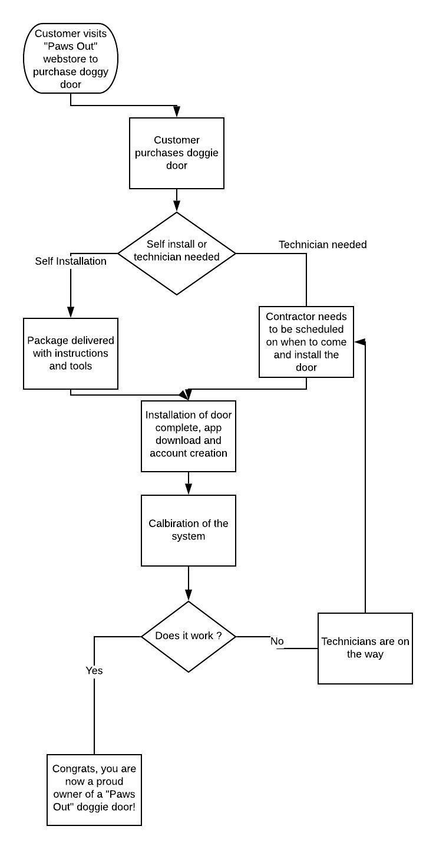

***Project Design Steps***

* Pick a material we choose to use for the Final Project presentation, In this case we chose to use a blank cardboard box which ended up being very professional looking, and making a door cut out to simulate the door opening and closing.
* The Project would need a Arduino Uno, RFID, 28BYJ - Stepper Motor, and Drivers, String (floss) to function, and code for it all to function together.
* Next was assembling the parts on the inside of the box as opposed to the outside, as we did for the midterm presentations, the RFID was located right next to the door cutout, along with the Arduino UNO and Stepper motor Driver located on the inside flap of the model. The stepper motor was then placed at the top of the box that was enclosed into a 3D printed case and 3D printed pulley system that held the floss (String) that would make the door go up and down.

# ***Software Code***

All of our initialization

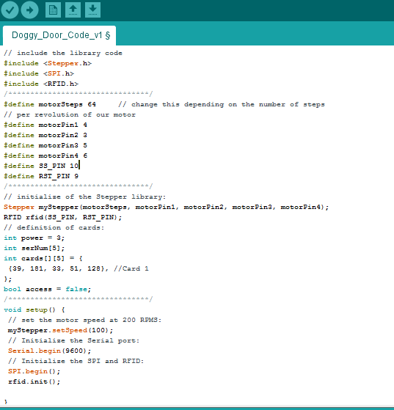

“If” statements that tells the system to read the key cards according to their initialized state. If it is the correct car, the door will open and display “Jefe’s Gotta Go Out”. If it the wrong card, the system will deny access.

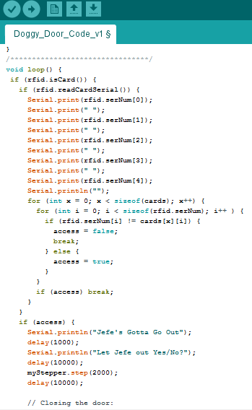

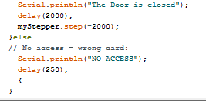

# ***Physical Prototype***

***Left Picture:***

Top Right- Stepper motor used to wind up cord.

Middle Left - Arduino RedBoard used to send power to RFID reader and stepper motor.

Bottom Center - RFID Reader used to identify correct and incorrect key card numbers.

***Right Picture:***

The door on the bottom moves up and down

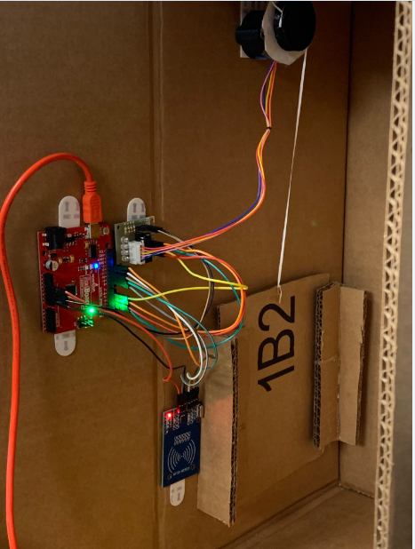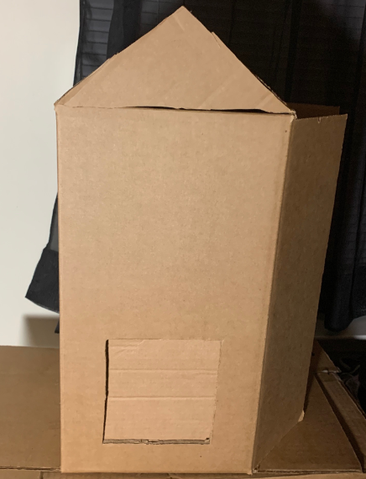

Blue and white key tags read by RFID

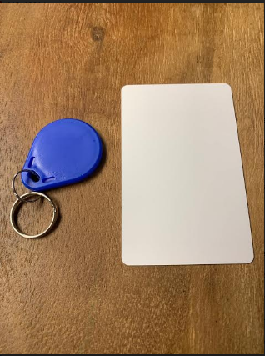

# ***6. Future Design Steps/Project Schedule***

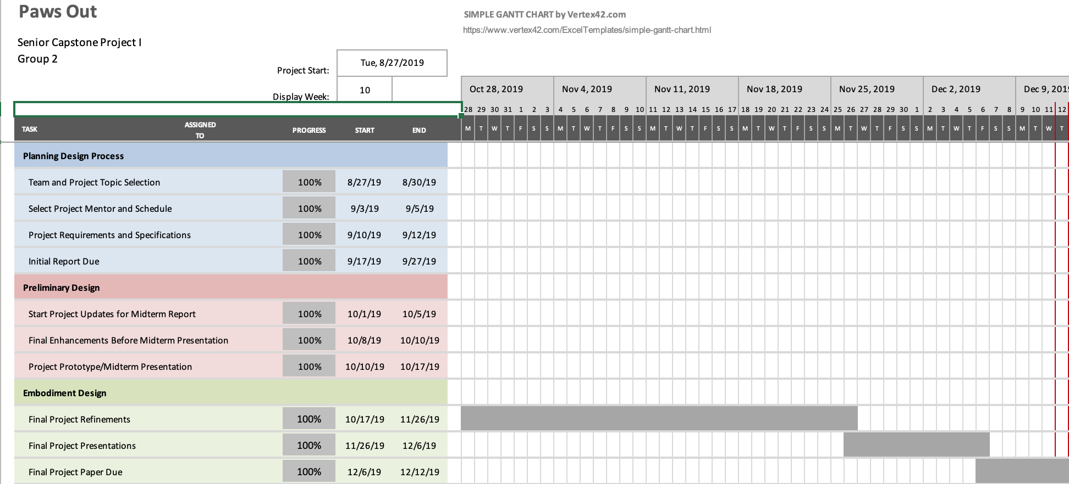

# 7. ***Learning Statements***

***Saivon Edens:***

At the beginning of this course, I was very concerned, the reason for being concerned was the fact that I did not know we would have to make something completely from scratch. I am not a very creative person, so to speak, I am usually able to go with a prompt and get the job done so this was going to be an interesting experience going in. When I had to pick a group I would normally pick a couple of friends but hence your advice that never ends well so I kept that to a minimum, this is where I met Daphane and got to know Daija and Kayla friends a lot better over time. We needed to pick a project idea and Daphane had the idea of a doggy door system and we just went from there seeing that none of us really had any other tangible ideas. So, we started work on the project, every week we decided the best day for us all to meet was Wednesdays at five o’clock in the library (club Bluford). In the library we got to know each other as group mates and I can say, I made a new friend and got to know the other two a lot better. We faced several challenges with this project, we needed to figure out what we wanted to make or show to you so that we could move on to the next class, from design to ideas on functions of the door. We had coding issues with our Arduino board, cable issues and even having a servo motor blow out and replace it just for the thing not to turn the amount of rotation we needed it to turn. We then needed to buy a new motor a stepper motor and had to change our whole code to work with the new motor, all this happened after the midterm report. We were able to make a model that looked professional, we decide to use a sturdy blank box to emulate a house and the door was supposed to be the doggy door, on the inside of the door we attached our Arduino, RFID, Stepper motor, and driver for the stepper motor, for the door we used another piece of cardboard and made channels for the inside of the door to keep it in track going up and down. For the string we attached floss to the cardboard door and made a 3D printed pulley system for the stepper motor seeing the motor did not have one. We assembled all the parts and presented it as our final and we were all excited and happy with the result as were you! Overall from this experience I have learned a plethora of things, one being working with people you do not know seeing that is something I will have to do in the work field when I get there. Overcoming complications was a second thing I learned from this project experience, being able when things aren't going right make a plan and execute to get things done, presentation skills increased because of this project as well. To wrap it up Teamwork is essential when working with others and team synergy and cooperation between each other is essential for reaching an end goal, these are things I hope to retain and use in future experiences as I succeed further in life.

***Daphane Walker:***

Overall the Doggie door was a great idea filled with challenges, accomplishments, and learned lessons. We as a group faced a lot of challenges when designing and implementing our ideas. In the beginning we were going to use mats on each side of the door, indicating to let the dog in/ out. Once we realized that it was too stressful to complete, we decided on using the dog’s collar instead. Two of the biggest challenges that we faced was programming the code and our motors. I was the Programmer in the group. I had background knowledge in Java and Python and stated that I was going to use Python as the language for the coding of Paw’s Out Doggie Door. The programming logic didn’t really cooperate with the Arduino that we were using to complete the project. This was my first time using an Arduino, prior to this class I had never heard of it. I read the instructions that came with the Arduino and seen that they had their own IDE. The programming language used in the project is C++. I had to do a lot of research for both the Arduino and the coding. In the beginning, we used a Servo motor. That motor only moved to certain degrees and/or angles. The first Servo motor we had, had burnt which caused us to have to use another one that didn’t really work as good. We realized that the Servo motor was broken, after numerous attempts of compiling/uploading code. We couldn’t hear the power in the Servo motor, which should’ve indicated that something was wrong. We never received an error message saying that it was an issue with the motor. When we switched to the second Servo, the gear that was on the previous Servo didn’t fit. We used a red dot as an indicator to show when the door was open and closed, but only could be seen it if a person was up close. We decided to get a new motor and purchased a Stepper motor. Once we changed from the Servo to a Stepper motor, we had to rewrite the code. We basically had to restart over from the beginning. When we had the RFID code and the code using the Servo motor, we didn’t have many issues. The only difficult encounter we had, was with the speed. As I stated before, the Servo motor could only do so much. The main issue/challenge that we faced this semester when completing this project was the COM3 error message. We used at least 2-3 different cords and our individual laptops, and we all received the same error. COM3 is a port that is used in Arduino IDE. My personal computer would switch from COM3 to COM4, and sometimes nothing at all. One minute everything would be working properly then once we compiled the new code the error would occur. The error message would state that the problem was not being able to connect to the red board, but the motor and RFID worked. You could hear the power from the motor as well as the RFID rotating the motor. The COM3 port, allowed us to see the output that stated that the dog had to use the bathroom. In our case, we used Jefe’ as the name for the dog.

We have numerous accomplishments while completing this project. The overall finished product is an accomplishment if you ask me. One accomplishment we had/shared was when we got the Servo and the RFID to work on the Arduino red board only. We didn’t want to use the Arduino, the white board and the RFID due to the numerous wires. Another accomplishment was the design of the door. We all had suggestions on how the door should look and where the wires should go. We didn’t want the wires to show while presenting. The design that we have now is a mixture of all our ideas, placed into one physical model. Seeing everything work together for the first time was an accomplishment. My personal accomplishment was seeing my idea flourish. I didn’t have a clue about creating a doggie door, until my group members suggestions and designs brought it to life.

Some lessons I have learned since starting this project is using an Arduino, C++ code, and patience. In the beginning, I didn’t know what an Arduino was. I did research and found out that Arduino’s really wasn’t as bad as I made it seem. I didn’t have any background knowledge of C++ and honestly, I still don’t. I can say that I have experienced or gained knowledge about C++, which sounds like a lesson learned to me. Finally, Patience. I had to realize that everything doesn’t happen when you want it to happen. The more we met to work on this project the patience I achieved. Going from one motor to another and starting from scratch boosted my patience level. If it wasn’t for the group, we wouldn’t have accomplished such a great project.

***Daija Stokes:***

At the beginning of this project, Paws Out, my group members and I thought this project did understand the technicalities of the project. We had a broad idea of the problem that we wanted to solve but no idea where to even start. We meet with professor Hogan and discussed the breakdown. During this conversation that we as a group had, we talked about the sensors that were supposed to be within the mat we were supposed to have. Our challenges in this project started off as being the whole project was not as easy as we thought it was going to be which is just opening and closing a door. After we discussed that we weren’t using the mats, we were introduced to the idea of using RFID sensors. These tags would be installed into the dog’s collar to be read by the RFID sensor installed into the door. We ordered the RFID and our next challenge was to write code which was neither one of our strong points. After watching numerous YouTube videos, we came across code that would be beneficial with what we needed to do. While using this code we discovered that it would not work with the specific RFID we had. We had to change the sensors RFID tag numbers located into the code to correlate with our tags code. We were successful and the RFID recognized the tag we had. Next was our servo, this was one problem that we never knew existed until we went and met with Professor Hogan once again. He told us that our servo that came with Kayla’s Arduino was burnt out. He then gifted us with one of his servos that served its purpose for our project. At one point in our project it was at a standstill. We were all getting irritated with even coming to class because our Arduino would never run consistently with the Arduino IDE. We tried everything at sometimes the ports would never show or our serial monitor that we used to see the acceptance of the RFID wouldn’t show. We consulted with other groups that were using Arduino and they let us borrow one of their extra Arduino USB cords so that we may try to resolve the problem. It worked, our inconsistencies with the project ceased and we realized our mistakes. When assembling the door, we were having design issues on how we actually wanted the door to open and how the strong should pull the door up. We tried using a box and a piece of floss to pull the piece of cardboard, but it never moved to be noticed. After research we discovered that our servo would no longer be beneficial to this project because it did not do full revolutions, which is what we needed to pull the cardboard. We then order stepper motors and driver boards that would be hooked to the Arduino board. As a group we didn’t know what attachment we would have to put on the stepper motor to turn the wheel. Saivon then used his 3-D printer to print an attachment so that it can act as a pulley which worked successfully. Although we were able to work out the major kinks in this section of the class and finalize out oral presentation to successfully open the door, there is still a long road ahead. One of the biggest challenges for me personally was my work schedule at the end of the year clashing with our group meeting schedule. I felt like I was missing out on valuable group time and I tried my hardest to make it so that I was active in the group discussion. My lesson I learned was that as much as we thought we were prepared we weren’t. The project seemed like it was going to be a simple breeze with just knowing the basic need of the door. But with patience we all stuck together the best we could to ensure that we would get it done. From the long nights staring at code that looked like a foreign language to all of us we pulled it together in the end.

***Kayla Gaston:***

From the very beginning, Dr. Sowells stressed to have different skill sets on your team. The example used was building a house: you need an electrician, a carpenter, an engineer and all other functioning pieces. That was probably the most import thing said during this semester. While each of our members had different skill sets, most of those skills couldn’t really be applied help for this portion of our project, which leads us into our biggest struggles.

The first obstacle that led to all other obstacles was that our project is mostly electronics based instead of IT. We started off a little scatter brained, trying to work on all parts of our project. Dr. Sowells suggesting that we just get the door moving was some crucial advice. Which would make sense because being that the mechanics of the door was the part we were least experienced in. I’ve had experience with the Arduino in an Internet of Things class I took with Professor Hogan sophomore year. Although I had this class, I wasn’t super skilled in it. Teaching my group members some basics of how the Arduino works and how to wire it up made me feel really helpful. Luckily, they are quick learners and once they understood that, we were all on the same playing field, learning together. So, aside from us not being electronics technology, there even bigger obstacles ahead. The major pieces of our project were a servo, used for our turning mechanism and our RFID reader and tags. We didn’t thing it was going to be as difficult as it was. We knew how to get the pieces to work separately but we just couldn’t get them to work together. Once we finally got the RFID reader to activate the servo, we started experiencing technical difficulties. Our COM port kept jumping from port to port. So, we would try to upload our code to the red board and it wouldn’t work so we’d switch the cord to a different port and it wouldn’t read there either. This also affected our serial monitor. This was really important to show because it was the only visual we had at the time. So, if that wasn’t working, we wouldn’t really have much to present. After our first presentation we came to a consensus that out USB was bad which affected our issues with the ports showing up. Kindly, another student let us borrow his cord until we could get our own. Which actually fixed our port problem. Now back to the turning mechanism. Taking the IoT class, I knew that a servo could turn a certain number of degrees. What id didn’t know is that it had a limit which we discovered as a team. So, here we are with one and a half weeks until final presentations. We knew we had to find a different turning mechanism and fast. Buying a new part so late in the game, we had to consider how long it was going to take to learn how to program it, make sure it was compatible with Arduino, and that it could turn as much as we needed it to. Thankfully, the new motor wasn’t hard to understand and program and we got everything working smoothly and rigged up in out prototype the night before presentations.

Personally, this project challenged my patience. The whole point of every milestone was to show proof of concept. All the obstacles we face made it seem like we didn’t know have solid understanding especially when it was time for presentations. Working so hard in the library or in smith after hours for hours, and then not getting it to work was really frustrating. When the semester is coming to an end, it’s so easy to slack off or slow down but with the final coming up and our project not working, that wasn’t an option. Patience also came into play when everyone wanted to troubleshoot with one Arduino. Part of being in a group is listening to everyone’s ideas and having an open mind. On another bright side, I got closer to two of my classmates that I had never even spoken to before. Going into next semester, I think we all can agree to go hard in the beginning even though we have a few months, the time slips away fast.